LAB 4 REPORT
Smart Optimization Assistant using Dynamic Programming

Student: Hemant Mukhiya
Course: BCA (AI & Data Science)Sem-5,Sec-A
Roll No: 2401201013

4.1 Introduction
Dynamic Programming (DP) solves problems by breaking them into overlapping subproblems, solving each subproblem once, and storing (tabulating) the results for reuse. This lab implements a 'Smart Optimization Assistant' using three classic DP algorithms: Longest Common Subsequence (sequence analysis), 0/1 Knapsack (resource allocation) and Matrix Chain Multiplication (computation optimization).

Problem Statement
Develop a Smart Optimization Assistant using Dynamic Programming to solve real-world optimization problems involving sequence analysis, resource allocation, and computation optimization. The system should implement Longest Common Subsequence (LCS), 0/1 Knapsack, and Matrix Chain Multiplication algorithms to generate optimal solutions, visualize Dynamic Programming tables, and analyze algorithm performance. It should provide an interactive interface, display intermediate computations, and present results through visualizations, complexity analysis, and performance reports.

Question 1: Implement the Sequence Analysis Module using the Longest Common Subsequence (LCS) algorithm. Display the DP table, longest common subsequence, and sequence length

Given two sequences, finds the length (and the actual subsequence) of the longest sequence of characters that appears, in order (not necessarily contiguously), in both. Solved bottom-up using a 2-D DP table.

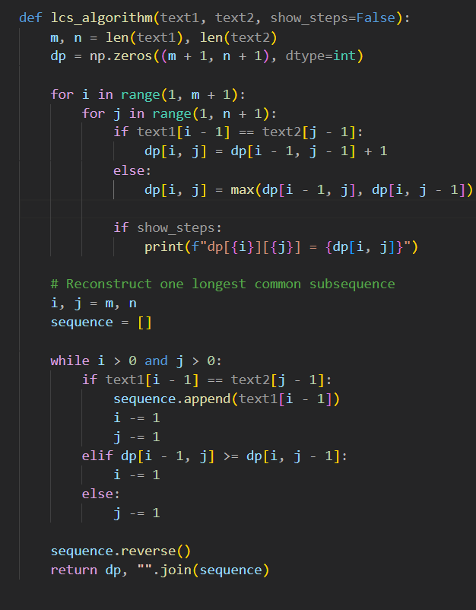
Python Code:

Complexity
Case | Time Complexity | Space Complexity
All cases O(m * n) | m, n = lengths of the two sequences; every table cell computed once | O(m * n) — for the DP table (reducible to O(min(m,n)) if only the length is needed)

Question 2: Implement the Resource Allocation Module using the 0/1 Knapsack algorithm. Display DP table construction, selected items, and maximum achievable profit.

Given items with weights and values and a knapsack of fixed capacity, choose a subset of items (each item taken whole or not at all) to maximize total value without exceeding capacity. Unlike Fractional Knapsack, greedy does not work here — Dynamic Programming guarantees the optimal answer.

Python Code:
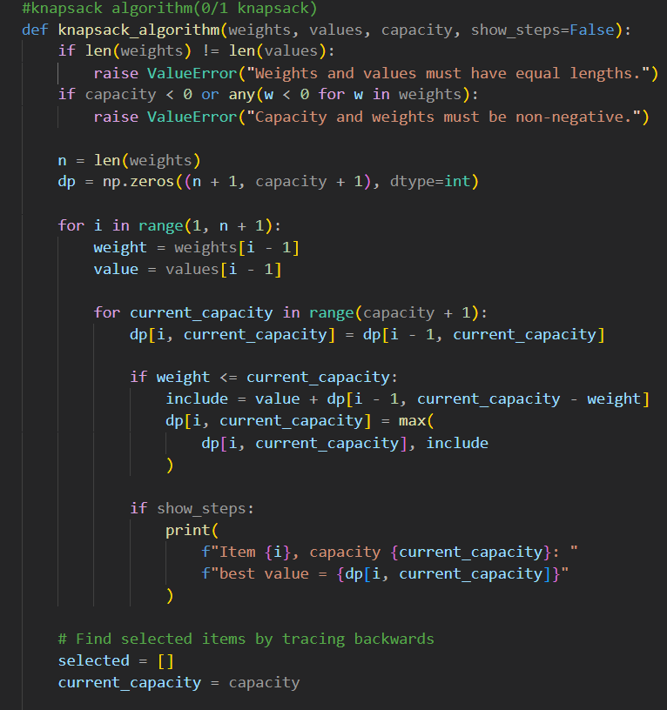

Complexity
Case | Time Complexity | Space Complexity
All cases O(n * W) | n = number of items, W = knapsack capacity (pseudo-polynomial) | O(n * W) — reducible to O(W) with a 1-D rolling array

Question 3: Implement the Computation Optimization Module using Matrix Chain Multiplication. Display cost tables, parenthesization tables, optimal multiplication order, and minimum cost.

Given a chain of matrices, finds the most efficient parenthesization (order of multiplication) that minimizes the total number of scalar multiplications — the matrices themselves are not multiplied, only the optimal order is computed.

Python Code:
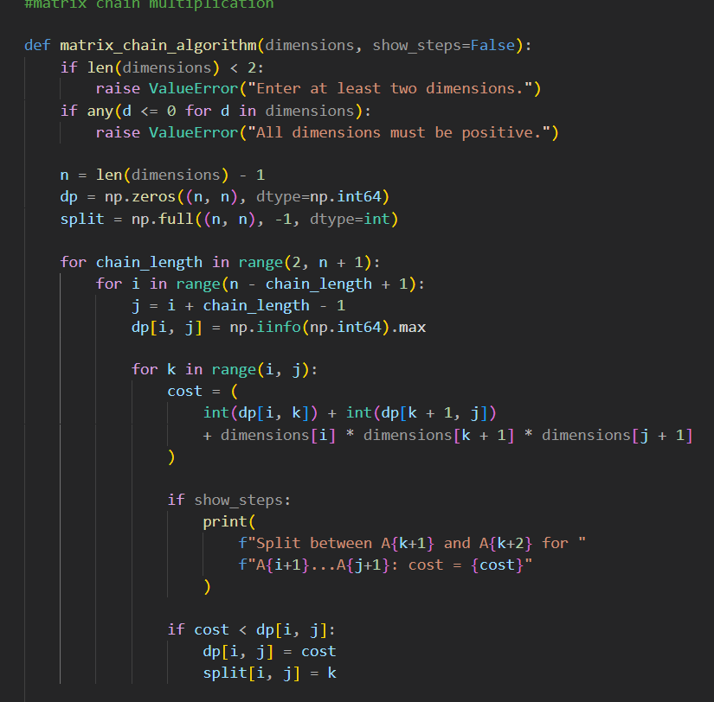

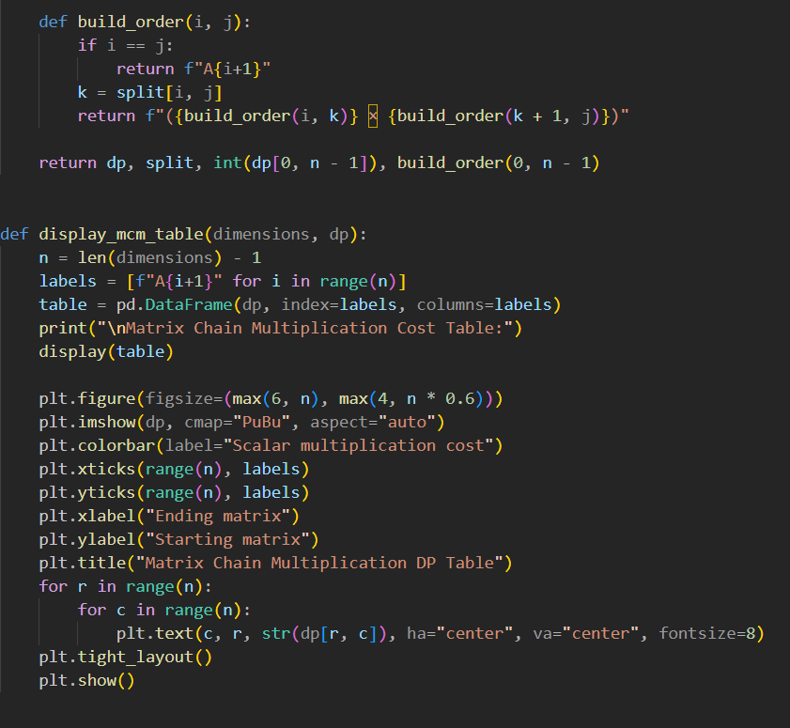

Complexity
Case | Time Complexity | Space Complexity
All cases O(n^3) | n = number of matrices; three nested loops (chain length, i, k) | O(n^2) — for the cost and split tables

Question 4: Measure execution time, space usage, and number of subproblems solved. Prepare a complexity comparison table for all Dynamic Programming algorithms.

Algorithm | Time Complexity | Space Complexity | # Subproblems
Longest Common Subsequence | O(m x n) | O(m x n) | m x n
0/1 Knapsack | O(n x W) | O(n x W) | n x W
Matrix Chain Multiplication | O(n^3) | O(n^2) | O(n^2) table entries

Question 5: Generate visualizations of DP tables, optimization results, performance statistics, and experimental observations for different problem sizes.

Visualize the DP tables directly (as heatmaps) so the bottom-up fill order and the optimal path are visible.

Python Code:
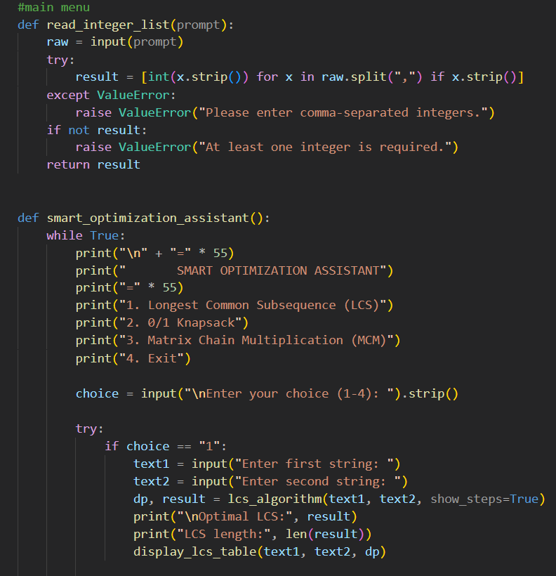
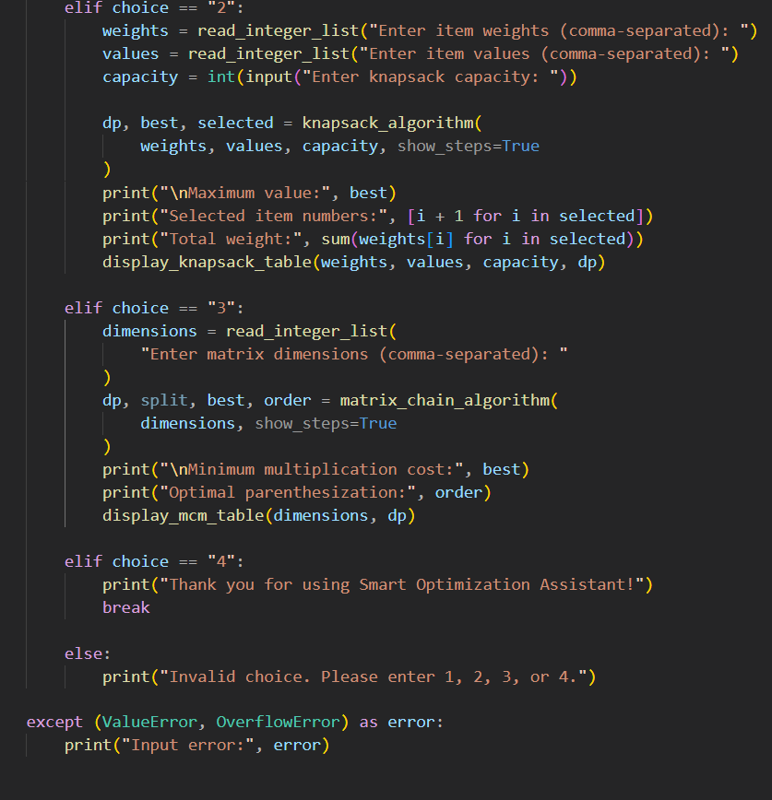

Conclusion

The Smart Optimization Assistant demonstrates how Dynamic Programming solves problems by breaking them into overlapping subproblems and storing previously computed results.

- LCS is useful in text comparison, version control, and DNA sequence analysis.
- 0/1 Knapsack models budget planning, cargo loading, and selecting projects under a fixed resource limit.
- Matrix Chain Multiplication optimizes the order of matrix operations in scientific and data-processing applications.

The notebook provides optimal results for the implemented problem definitions, displays intermediate DP tables, and compares observed performance with theoretical complexity.

